***Documentation***

**Title:** EqualiTECH - Human Rights Hackathon

**Project description:**

EqualiTECH was a regional hackathon aimed at leveraging the technological potential of young people in the Western Balkans to combat injustice and inequality. The event took place from December 11-13, 2020, and involved five teams and five mentors. The teams, each consisting of three to four members, worked on developing innovative solutions during the weekend event. The hackathon aimed to foster collaboration among tech enthusiasts and activists from Kosovo, Albania, Macedonia, and Bosnia and Herzegovina.

**Activities:**Key activities:

* **Opening Remarks:** The event kicked off at 17:45 on Friday with opening remarks from Philip Merrell of CRD and Arianit Dobroshi from FLOSSK.
* **Keynote Speech:** A keynote address was delivered by Marcin de Kaminski, Director of Human Rights Defenders at the Risk Department.
* **Team Work:** On Saturday, teams spent around seven hours collaborating and developing their ideas, with the support of mentors who were available for guidance and answering questions.
* **Mentorship and Feedback:** Mentors provided ongoing advice to the teams during the weekend to refine their ideas.
* **Final Presentations:** On Sunday, teams prepared for their final presentations, which were delivered at 17:00. Staff and mentors offered feedback and support to ensure the teams were ready.

**Photos:**

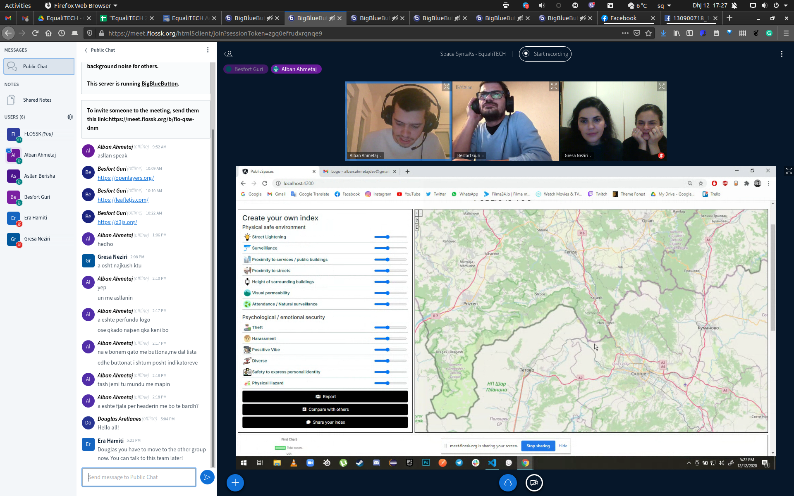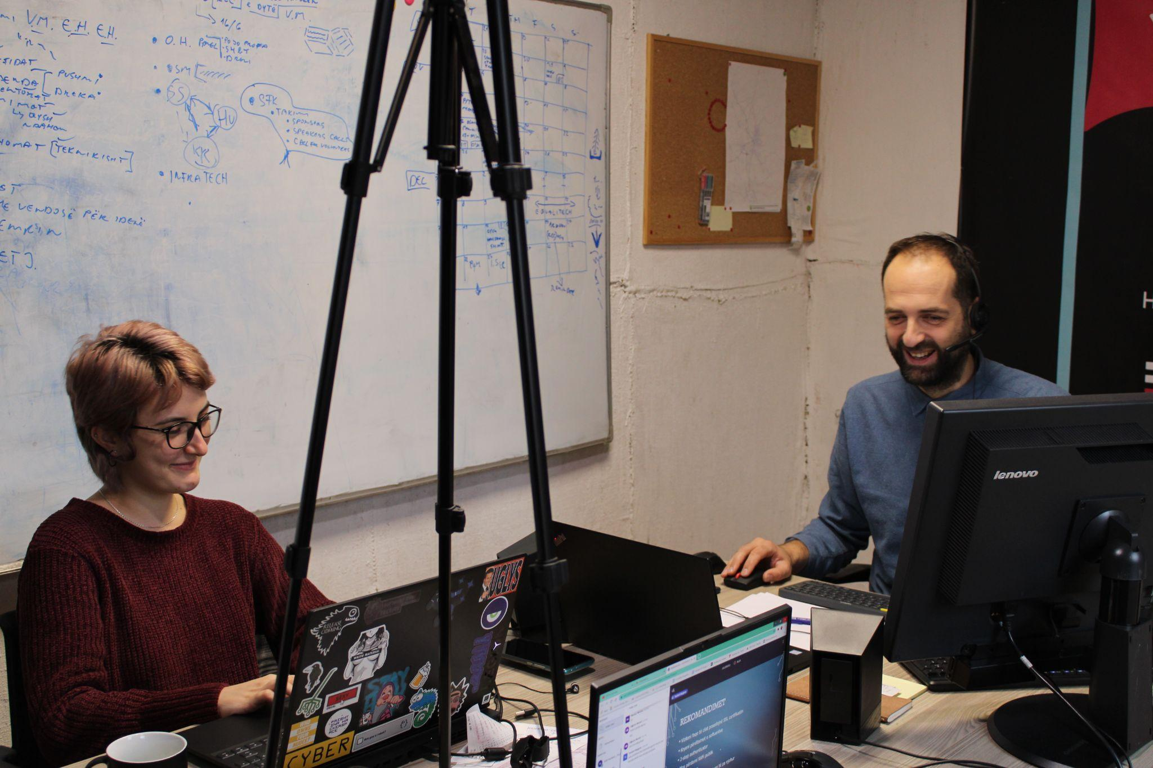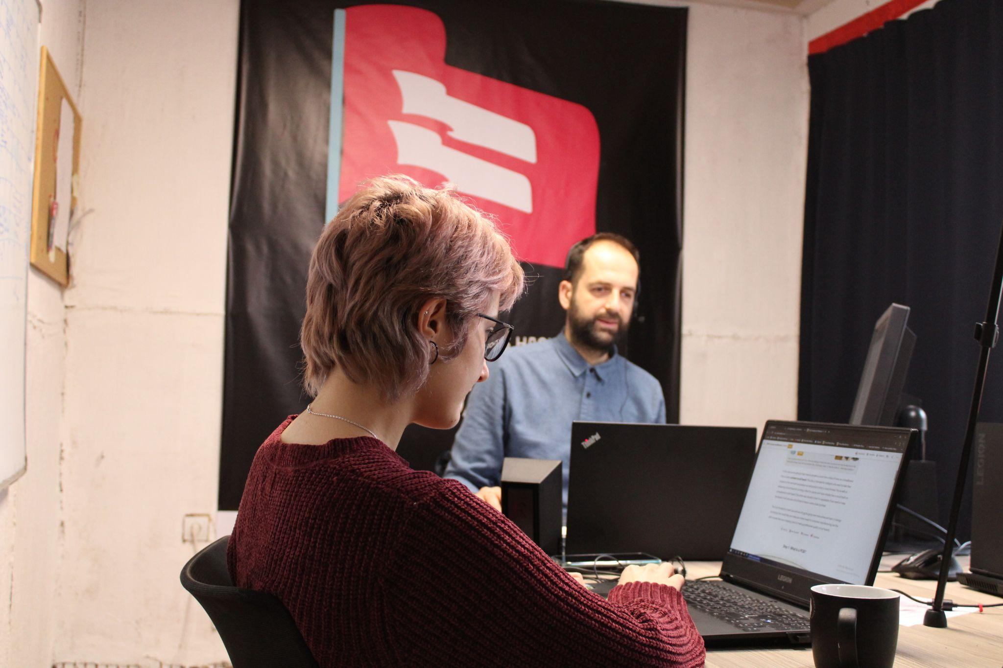

**Beneficiaries:**

Participants from Kosovo, Albania, Macedonia, and Bosnia and Herzegovina, aged 18-40, benefited from the hackathon by developing new skills and contributing to projects aimed at addressing injustice and inequality.

**Partners:**

* CRD (Centre for Regional Development)
* FLOSSK (Kosovo Free and Open Source Software Association)
* Ipko Foundation
* YIHR (Youth Initiative for Human Rights)

**Budget:  
€**

**Project duration**:

*This document is FLOSSK intellectual property - Do not share without authorization from FLOSSK.*